Insert School Logo

Semester One

Examination 2020

Question/Answer booklet

MATHEMATICS
SPECIALIST UNIT 1

Section Two:
Calculator–assumed

Student Name: _____________________________________

Teacher’s Name: _____________________________________

Time allowed for this section
Reading time before commencing work: ten minutes
Working time for paper: one hundred minutes

Material required/recommended for this section

To be provided by the supervisor
This Question/Answer booklet
Formula Sheet (retained from Section One)

To be provided by the candidate
Standard items: pens (blue/black preferred), pencils (including coloured), sharpener, correction tape/fluid, erasers, ruler, highlighters

Special Items: drawing instruments, templates, notes on two unfolded sheets of A4 paper, and up to three calculators approved for use in the WACE examinations.

Important note to candidates
No other items may be taken into the examination room. It is your responsibility to ensure that you do not have any unauthorised notes or other items of a non–personal nature in the examination room. If you have any unauthorised material with you, hand it to the supervisor before reading any further.

Structure of this paper

 | Number of questions available | Number of questions to be attempted | Working time (minutes) | Marks available | Percentage of exam
Section One  Calculator—free | 6 | 6 | 50 | 50 | 35
Section Two  Calculator—assumed | 12 | 12 | 100 | 100 | 65
 |  |  |  | Total Percentage | 100

Instructions to candidates

- The rules for the conduct of Western Australian external examinations are detailed in the
Year 12 Information Handbook 2020. Sitting this examination implies that you agree to abide by these rules.

- Answer the questions according to the following instructions.

Show all your working clearly. Your working should be in sufficient detail to allow your
answers to be checked readily and for marks to be awarded for reasoning. Incorrect answers given without supporting reasoning cannot be allocated any marks. For any question or part question worth more than two marks, valid working or justification is required to receive full marks. If you repeat an answer to any question, ensure that you cancel the answer you do not wish to have marked.

It is recommended that you do not use pencil, except in diagrams.

- You must be careful to confine your responses to the specific questions asked and to follow any instructions that are specific to a particular question.

- Spare pages are included at the end of this booklet. They can be used for planning your responses and/or as additional space if required to continue an answer.
- Planning: If you use the spare pages for planning, indicate this clearly at the top of the page.
- Continuing an answer: If you need to use the space to continue an answer, indicate in the original answer space where the answer is continued, i.e. give the page number. Fill in the number of the question that you are continuing to answer at the top of the page.

- The Formula Sheet is not handed in with your Question/Answer Booklet.

Section Two: Calculator–assumed 65% (100 marks)

This section has twelve (12) questions. Attempt all questions. Write your answers in the spaces
provided.

Spare pages are included at the end of this booklet. They can be used for planning your responses
and/or as additional space if required to continue an answer.

- Planning: If you use the spare pages for planning, indicate this clearly at the top of the page.
- Continuing an answer: If you need to use the space to continue an answer, indicate in the original answer space where the answer is continued, i.e. give the page number. Fill in the number of the question(s) that you are continuing to answer at the top of the page.

Working time: 100 minutes

Question 7 (6 marks)

Three horses are pulling a cart when they panic and run in different directions.

Horse A pulls with a force of 30 Newtons on a bearing of N60°W.
Horse B pulls with a force of 22 Newtons on a bearing of S45°W.
Horse C pulls with a force of 42 Newtons on a bearing of $\text{θ}$.

Given that the cart moves directly East, determine the bearing Horse C runs on and the
speed with which the cart moves. (Assume Horse C moves in the first quadrant.) (6 marks)

Question 8 (13 marks)

(a) Consider the diagram below.
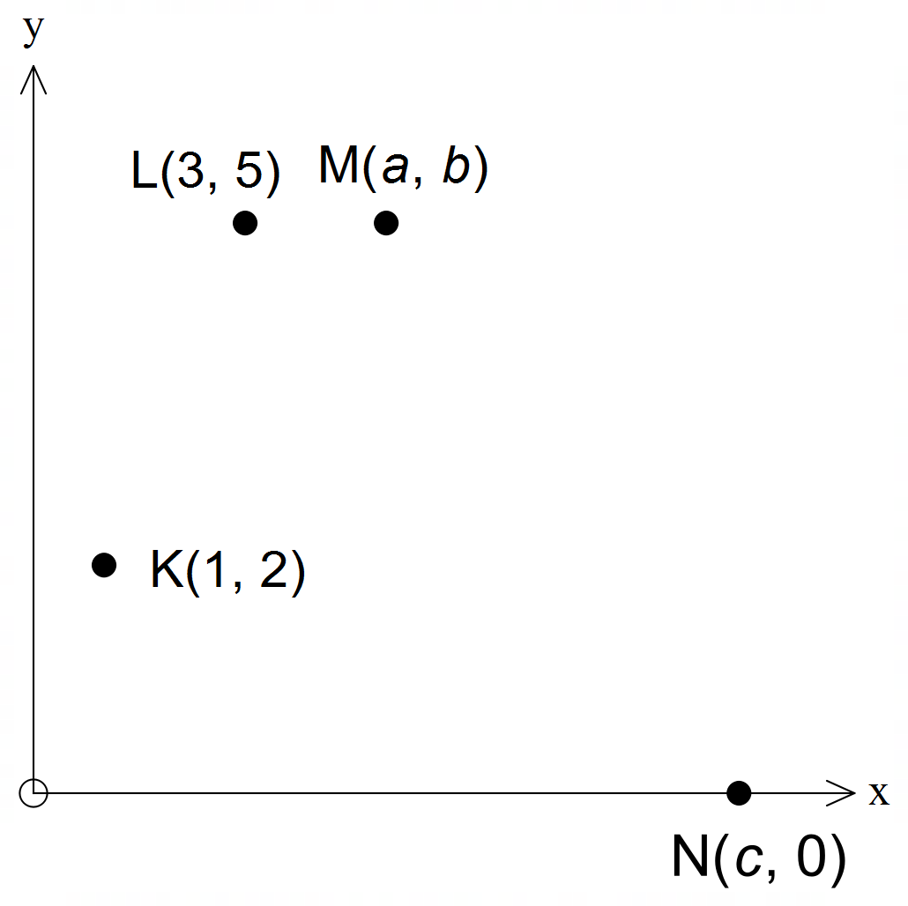

(i) Show that the coordinates of M are (5, 5) if: (3 marks)
- |KM| = 5;
- a > 3; and
- LM is parallel to the x–axis.

(ii) Determine c if 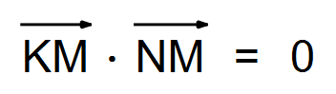. (2 marks)

(Question 8 continued)

(b) Consider the quadrilateral formed by the points in the diagram below.
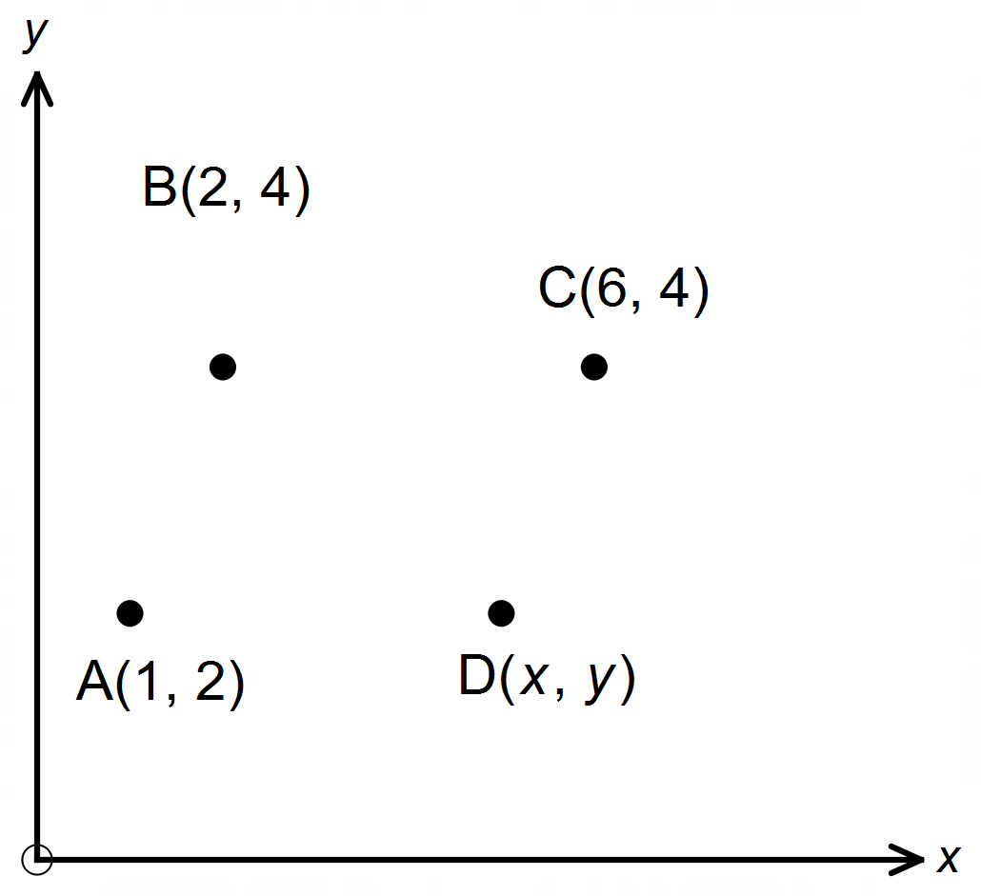

Use a vector method to:

(i) find x and y given ABCD is a parallelogram. (2 marks)

(ii) determine the condition(s) required in terms of x and/or y so that ABCD is a trapezium.

(4 marks)

(iii) show that points A and B and the origin are collinear. (2 marks)

Question 9 (7 marks)

A commercial airplane flies from City A to City B. The commercial airplane can fly at a cruising speed of 940 km/h in still air. City B is 4350 km from City A on a bearing of 100°T. There is a wind blowing from a bearing of 170°T at a speed of 190km/h.

(a) Use the axes below to create a vector diagram of the situation. (2 marks)
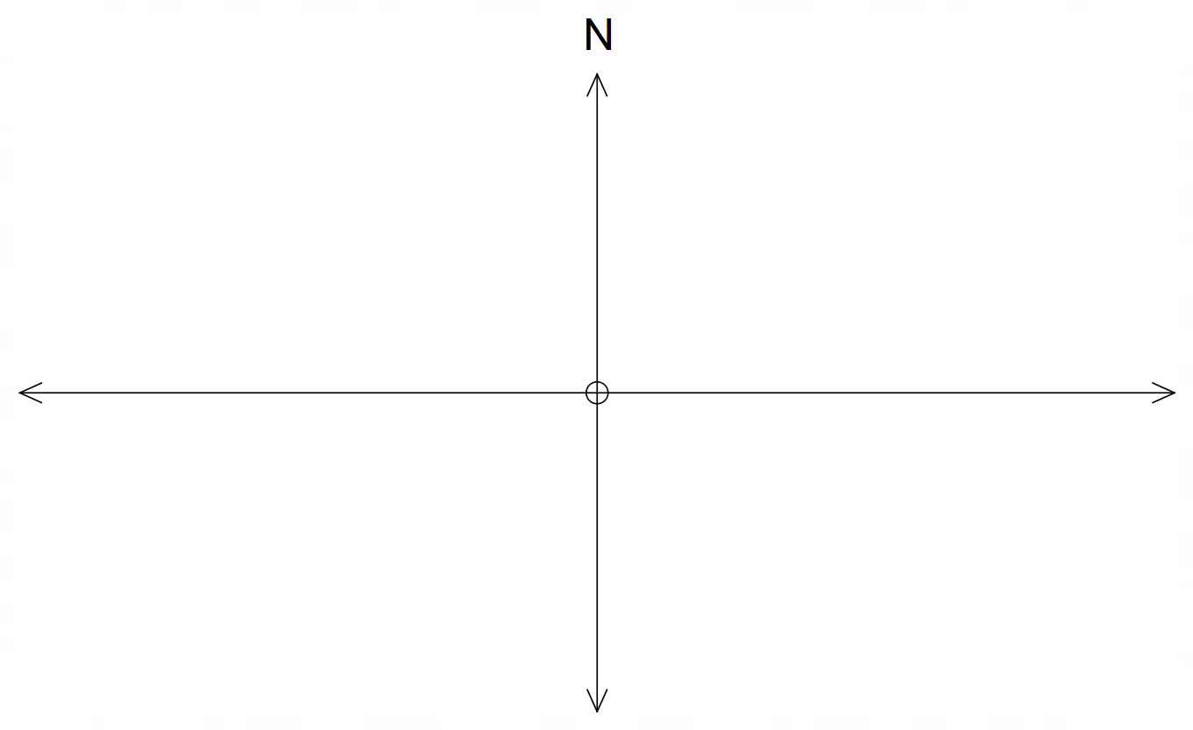

(b) Determine the true bearing of the direction the pilot should set in order to fly directly
from City A to City B. (2 marks)

(c) Determine the duration of the journey correct to the nearest minute. (3 marks).

Question 10 (8 marks)

At a college, 100 students are randomly selected.
70 like tea, 50 like coffee and 20 like both.

(a) How many like tea only? (1 mark)

(b) How many like neither drink? (1 mark)

When the same students were asked about fruit juice, there were 60 likes.
40 of these liked tea and 30 liked coffee.

(c) Determine the number who liked all three beverages. (3 marks)

(d) If one of the survey group was selected at random, find the probability he/she would like:

(i) at least two of the beverages. (1 mark)

(ii) only tea. (1 mark)

(e) State the minimum number of students that could be selected to ensure that
at least one fruit juice drinker was among them? (1 mark)

Question 11 (8 marks)

The quadrilateral OABC shown is a trapezium with $\overline{\text{OA}}$ = $\text{3}\overline{\text{CB}}$. Let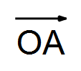= a and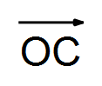= c.
E and F are the midpoints of the diagonals $\overline{\text{OB}}$ and $\overline{\text{AC}}$ respectively.
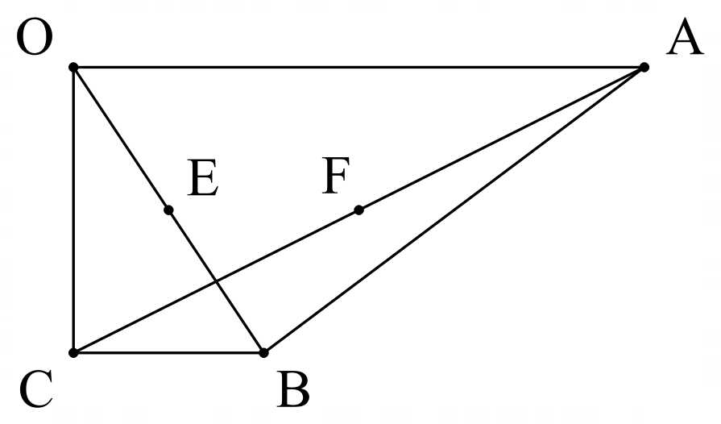

(a) Determine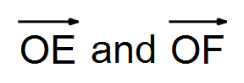in terms of a and/or c. (4 marks)

(b) Prove that CEFB is a parallelogram. (4 marks)

Question 12 (7 marks)

Consider the following statements.

A: If $m>n$, with $m,n∈R$, then $- m>- n$.
B: If the triangle has two equal length sides, then the triangle is isosceles.
C: $∀ p∈N,∃ q∈R$ such that $q=p-1$
D: If $n$ is divisible by 8, then $n$ is divisible by 4.

(a) Provide a counter example for statement A. (1 mark)

(b) Write down the contrapositive of statement B.
Is the contrapositive always true? Explain. (2 marks)

(c) Write down the converse of statement D.
Is the converse always true? Explain. (2 marks)

(d) Rewrite statement C in words. (2 marks)

Question 13 (10 marks)

(a) If a quadrilateral can be circumscribed by a circle, prove that each pair of
opposite angles sums to 180°. (4 marks)



(b) ABCD is a cyclic quadrilateral. Bisector of ∠BEC intersects BC at F and AD at G.
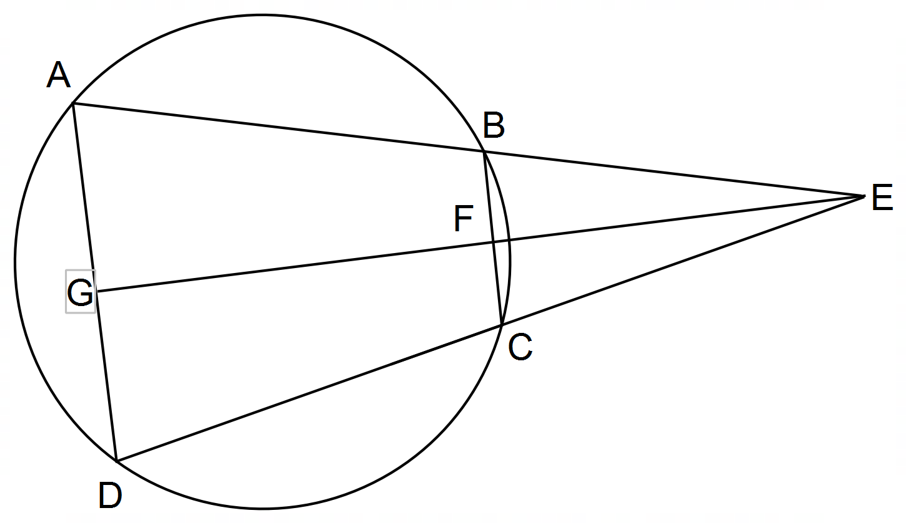 Prove : ∠AGF = ∠BFG (4 marks)

(Question 13 continued)

Consider the statement:
“If the opposite angles of a quadrilateral are supplementary, then the quadrilateral is cyclic.”

(c) (i) In relation to the theorem in (a), this statement is which of the following?
converse, negation, inverse or contrapositive (1 mark)

(ii) Is the statement true? (1 mark)
Question 14 (14 marks)

Three vectors are given by a = 5i – 3j, b = −8i + j and c = xi – 8j, where x is a constant.

Determine the value(s) of x if:

(a) (i) b and c are perpendicular. (2 marks)

(ii) the angle between a and c is 60°. (3 marks)

(iii) the magnitude of c is twice that of a − b. (3 marks)

(Question 14 continued)

(b) A triangle is formed by three non–zero vectors, a, b and c, so that a = b – c, and θ is the angle between b and c.

- Sketch and clearly label the triangle with the pronumerals a, b, c and θ. (2 marks)

(ii) Explain, why a ∙ a = |a|². (1 mark)

(iii) Use a ∙ a = (b – c) ∙ (b – c) to prove the cosine rule. (3 marks)

Question 15 (10 marks)

A Physics teacher has a three way tug−of−war rope.
He is experimenting with his class.

The first experiment involves forces being applied to the rope as shown in Diagram 1.
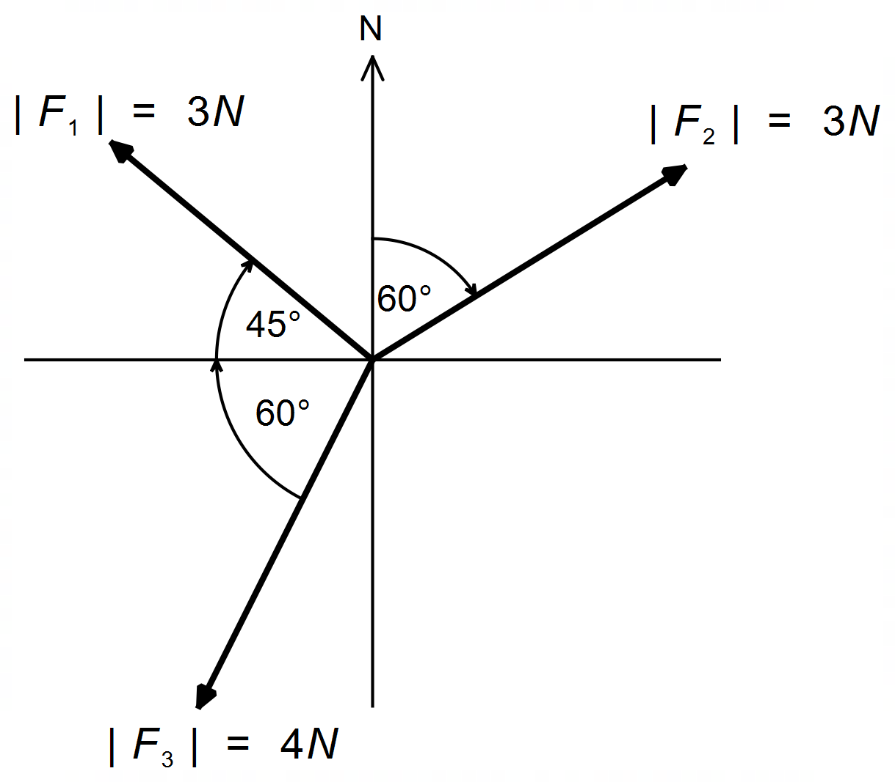

(a) Determine the direction, correct to the nearest degree, of the resultant force experienced
by the origin of the system. (6 marks)

(Question 15 continued)

The second experiment involves keeping the rope in equilibrium using the forces as shown.
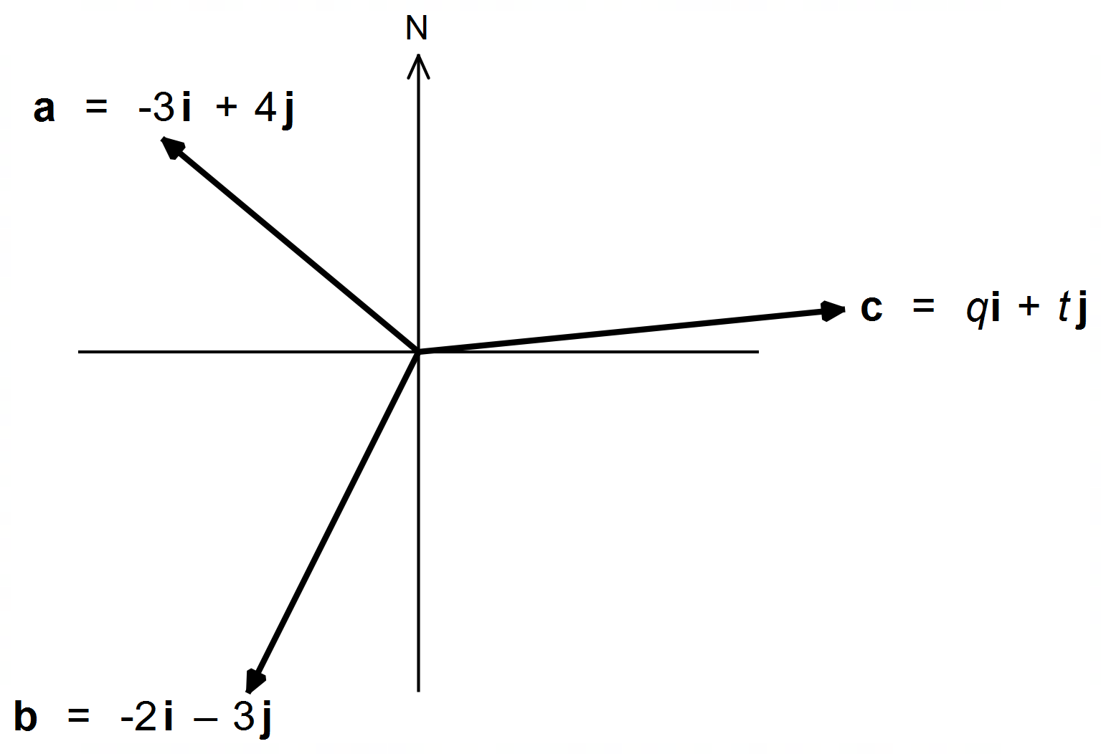

(b) Determine the magnitude and direction, to the nearest degree, of c. (4 marks)

Question 16 (4 marks)

ABCD is a cyclic quadrilateral with diagonals intersecting at E. The line PQ is perpendicular
to the side AD and passes through E. Given | EQ | = | BQ | = | QC |, prove that the diagonals
of the cyclic quadrilateral are perpendicular.
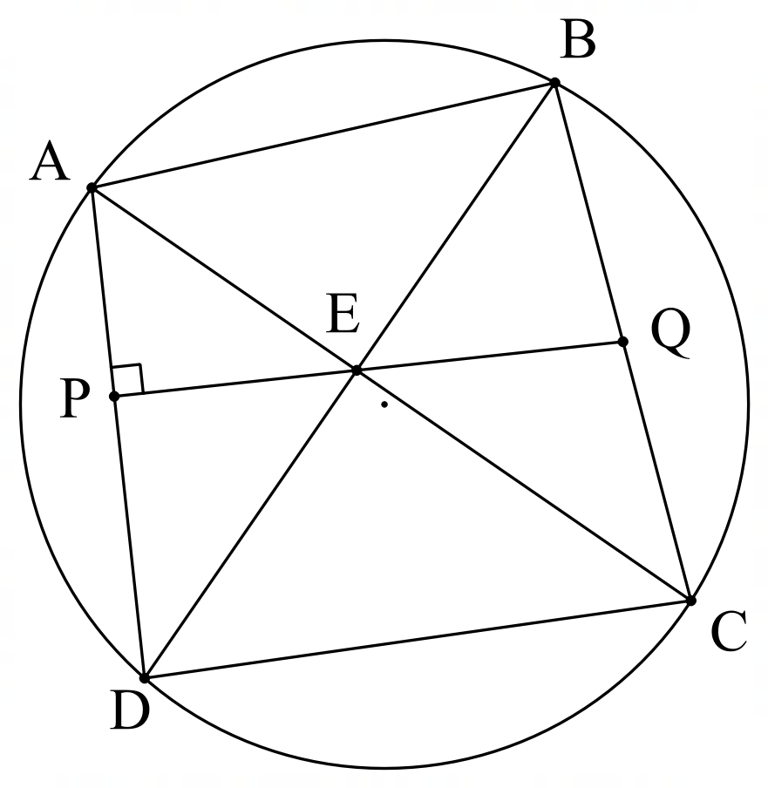

Question 17 (5 marks)

Solve for n, if 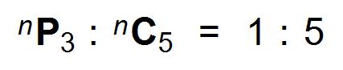 (5 marks)

Question 18 (8 marks)
(a) Find the term independent of x in the expansion of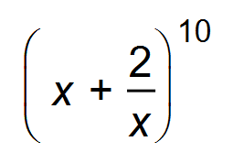 (3 marks)

(b) Show that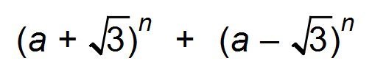contains no surds. (5 marks)

End of questions
Additional working space

Question number(s): ……………………

Additional working space

Question number(s): ……………………

